**Internet of Things**

The "Internet of things" (IoT) is becoming an increasingly growing topic of conversation both in the workplace and outside of it. It's a concept that not only has the potential to impact how we live but also how we work. But what exactly is the "Internet of things" and what impact is it going to have on you, if any? There are a lot of complexities around the "Internet of things" but I want to stick to the basics. Lots of technical and policy-related conversations are being had but many people are still just trying to grasp the foundation of what the heck these conversations are about.

Let's start with understanding a few things.

Broadband Internet is become more widely available, the cost of connecting is decreasing, more devices are being created with Wi-Fi capabilities and sensors built into them, technology costs are going down, and smartphone penetration is sky-rocketing.  All of these things are creating a "perfect storm" for the IoT.

**So What Is The Internet Of Things?**

Simply put, this is the concept of basically connecting any device with an on and off switch to the Internet (and/or to each other). This includes everything from cellphones, coffee makers, washing machines, headphones, lamps, wearable devices and almost anything else you can think of.  This also applies to components of machines, for example a jet engine of an airplane or the drill of an oil rig. As I mentioned, if it has an on and off switch then chances are it can be a part of the IoT.  The analyst firm [Gartner](https://www.forbes.com/companies/gartner/) says that by 2020 there will be over 26 billion connected devices... That's a lot of connections (some even estimate this number to be much higher, over 100 billion).  The IoT is a giant network of connected "things" (which also includes people).  The relationship will be between people-people, people-things, and things-things.

**How Does This Impact You?**

The new rule for the future is going to be, "Anything that can be connected, will be connected." But why on earth would you want so many connected devices talking to each other? There are many examples for what this might look like or what the potential value might be. Say for example you are on your way to a meeting; your car could have access to your calendar and already know the best route to take. If the traffic is heavy your car might send a text to the other party notifying them that you will be late. What if your alarm clock wakes up you at 6 a.m. and then notifies your coffee maker to start brewing coffee for you? What if your office equipment knew when it was running low on supplies and automatically re-ordered more?  What if the wearable device you used in the workplace could tell you when and where you were most active and productive and shared that information with other devices that you used while working?

On a broader scale, the IoT can be applied to things like transportation networks: "smart cities" which can help us reduce waste and improve efficiency for things such as energy use; this helping us understand and improve how we work and live. Take a look at the visual below to see what something like that can look like.

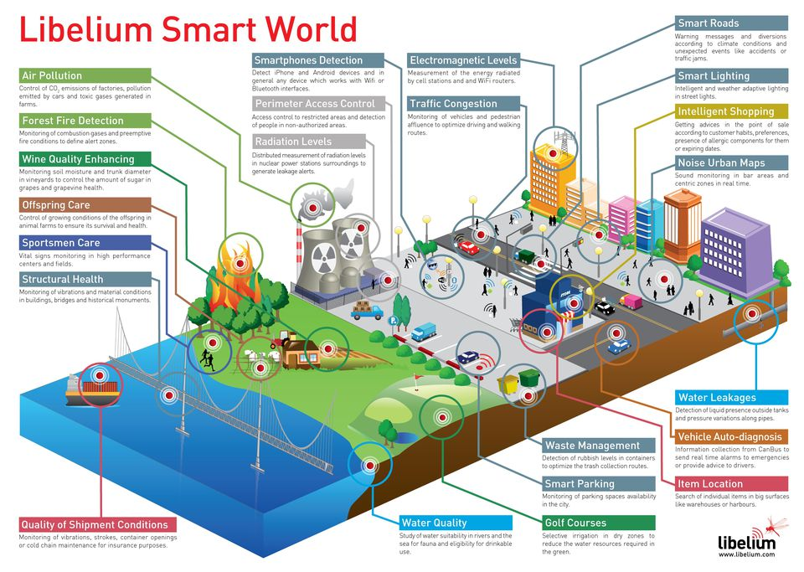

The reality is that the IoT allows for virtually endless opportunities and connections to take place, many of which we can't even think of or fully understand the impact of today. It's not hard to see how and why the IoT is such a hot topic today; it certainly opens the door to a lot of opportunities but also to many challenges. [Security](http://www.forbes.com/security/) is a big issue that is oftentimes brought up. With billions of devices being connected together, what can people do to make sure that their information stays secure? Will someone be able to hack into your toaster and thereby get access to your entire network? The IoT also opens up companies all over the world to more security threats. Then we have the issue of privacy and data sharing. This is a hot-button topic even today, so one can only imagine how the conversation and concerns will escalate when we are talking about many billions of devices being connected. Another issue that many companies specifically are going to be faced with is around the massive amounts of data that all of these devices are going to produce. Companies need to figure out a way to store, track, analyze and make sense of the vast amounts of data that will be generated.

**So what now?**

Conversations about the IoT are (and have been for several years) taking place all over the world as we seek to understand how this will impact our lives. We are also trying to understand what the many opportunities and challenges are going to be as more and more devices start to join the IoT. For now the best thing that we can do is educate ourselves about what the IoT is and the potential impacts that can be seen on how we work and live.

**IOT Platforms**

Internet of Things is an emerging technology that connects billions of smart devices and sensors to internet with an efficient, secure and convenient way. In order to develop IoT ecosystem, it requires a development environment called IoT development platform where we design and manage solutions for each applications. Here are the top Internet of Things (IoT) development platforms.

### **What is IoT development platform?**

Internet of Things will enable companies to create new data driven services, cloud data processing, and predictive analytics. IoT development platform is like an Integrated Development Environment (IDE) which provides a powerful toolkit for IoT development and  complete end to end solution to develop, deploy and manage IoT applications.

An IoT platform connects devices, smart sensors and IoT gateways to the cloud. Since [IoT](https://www.rfpage.com/scope-rf-technology-internet-of-things/) operates in many areas, IoT platform should be able to handle huge amount of data from devices, sensors, websites, and applications efficiently. It has a real-time analytics option to monitor network activities.

### **1. Amazon Web Services (AWS)**

Amazon Web Services IoT is a managed cloud platform designed for Internet of Things applications, it allows unlimited number of devices and sensors to interact with cloud applications securely. Moreover, AWS supports all the popular software development kits (SDKs) like Embedded C, JavaScript, Python, Java and iOs for applications development.

AWS offers super charged dedicated servers for any complex applications and it has the capability to handle millions of devices and huge data rate.

### **2. Microsoft Azure IoT**

Microsoft offers Asure IoT Suite and Asure IoT Hub for developers to create applications, manage devices remotely and analyze data in real-time. It has the flexibility to operate with multiple operating systems and platforms.

Azure cloud platform uses Microsoft Visual Studio SDK which is familiar to millions of developers. In addition, integration with other cloud solutions and web applications make Azure on the top IoT platform list.

### **3. Google Cloud IoT**

Google Cloud IoT platform is another powerful managed and integrated service which offers complete solution for development and management of millions of connected devices across the globe. Sophisticated analytics tool lets companies to get an insight in real-time manner.

End-to-end security, integrated services with cloud, advanced data analytics, business process optimization and fully managed infrastructure are the core features of Google Cloud IoT platform.

### **4. IBM – Watson IoT Platform**

Watson IoT platform from IBM is one the leaders in IoT development system which offers total solution for application development, management of devices, cloud database and real-time data analytics. IBM claims to have developed strong analytical solution for cognitive analytics in Internet of Things.

IBM has been investing heavily on IoT ecosystem, Watson offers cost effective solutions for supply chain management and payment processing. It helps to completely manage IoT solutions and make business decision based on the strong real-time analytics data.

### **5. ThingWorx IoT Platform**

ThingWorx also an emerging IoT platform offers solutions with cost effective, reduced risk and reduced development time. It has flexible solution for deployment with complete applications design, run-time and intelligence environment.

ThingWorx claims faster development, integration and deployment for multiple IoT solutions. It gives flexibility and scalability for future developments and upgrades.

### **6. Predix IoT Platform**

Predix is one of the new IoT platforms from Apple and GE which primarily designed for industrial IoT and provides tools for software development. It allows customers and business partners to develop and manage their IoT devices and solutions.

Predictive maintenance is one the most important factor in industrial operation. Predix can efficiently analyze data, intelligently predicts and inform the control centre to take necessary steps to avoid any critical events.

### **7. Cisco IoT Platform**

Cisco IoT platform provides simple and secure solutions for IoT with network connectivity, data analytics, application enablement, management and automation.  It promises a secure platform to connect millions of devices from different geographical area effectively.

It can support industrial automation, power management, smart city and transportation system.

### **8. Samsung ARTIK**

Samsung has recently launched its development solution for Internet of Things applications. It provides a wide range of modules to connect with IoT products from simple sensors to complex hubs.

Miniaturized solution for multiple applications is one of the top features of ARTIK modules.

### **9. HP Enterprise Universal IoT Platform**

With HPE’s universal IoT platform, customers can connect to a strong system with scalability, modularity and versatility. It allows customers to monetize from the massive data collected from millions of devices and smart sensors across different areas of applications.

Secure monetization, simultaneous management, accurate data analytics, built-in application designer and marketplace and cross-vertical operations are the key feature of HPE Universal IoT platform.

**Other IoT platforms**

Raspberry Pi 2, Intel’s Galileo, Apple’s HomeKit, Qualcomm’s IoT development kit, Analog device’s Connect are other IoT development platforms for connected devices.

### **Conclusion**

According to predictions, billions of new smart devices and sensors will be connected to internet in coming years. It requires an efficient, secure and cost effective platform to develop, deploy and manage wide variety of applications for industries, smart cities, home automation, connected cars, medicine & healthcare, smart farming, logistics and supply chain management etc… Technology advancements in [wireless](https://www.rfpage.com/top-wireless-technologies-iot-5g-networks/) transmission, data encryption and network protocol will ensure a secure and smart IoT network for future.